# ANALYZING THE DATA

We will analyze the data to see which function should we use to the prediction.

### Square foot – Price

The relation here is pretty linear in distinct neighborhoods.

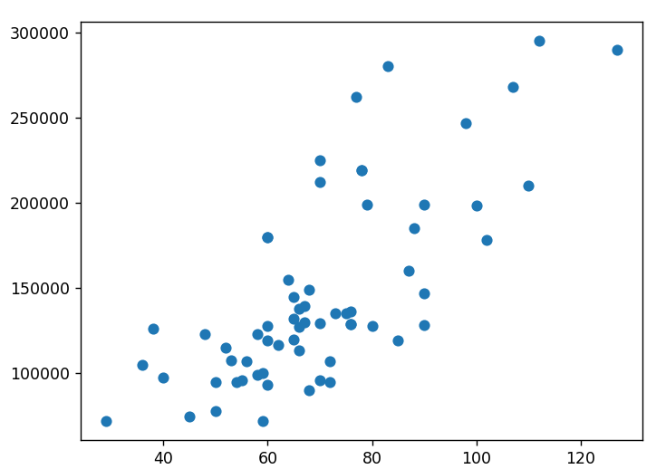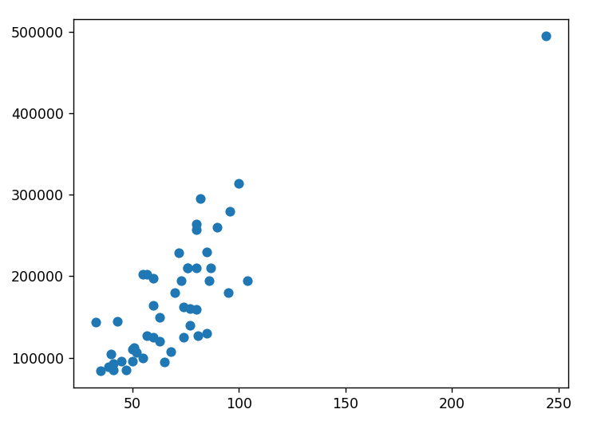

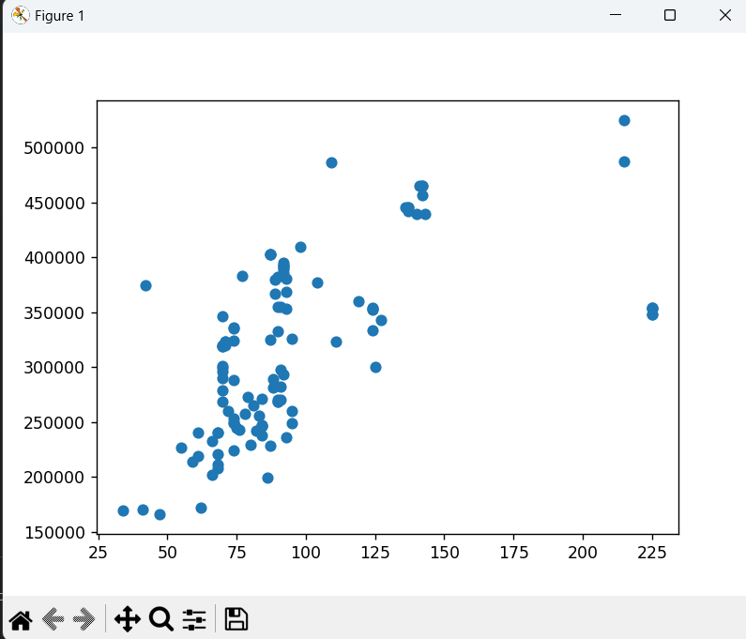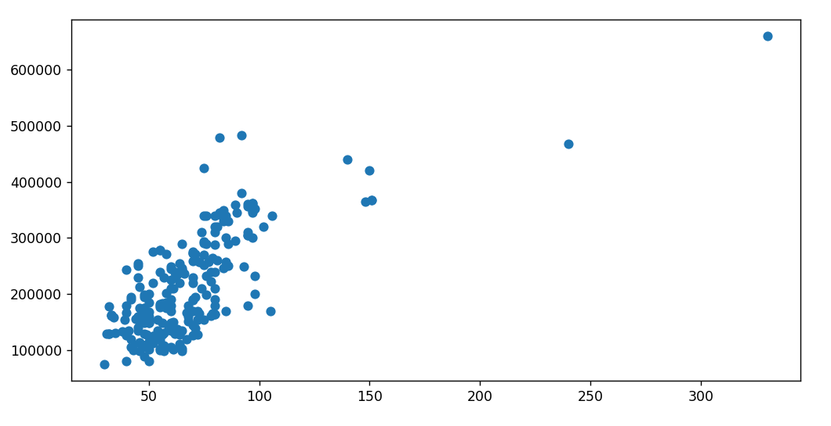

### Number of rooms – Price

We could interpret the relation with an exponential formula. May be not relevant. There are neighborhoods that don’t have that relation.

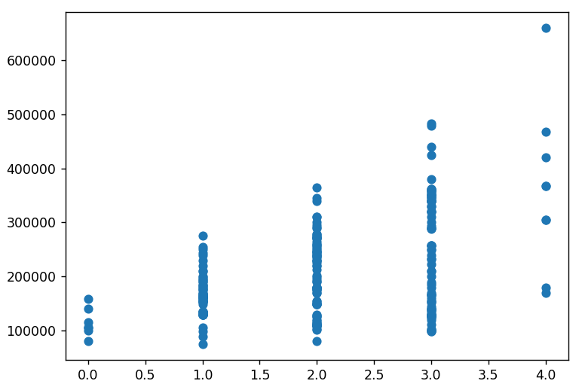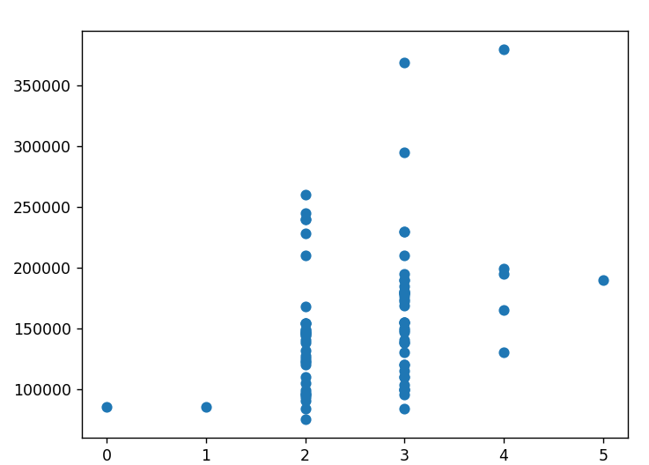

### Number of bathrooms – price

The relation might be linear. Relevant for price

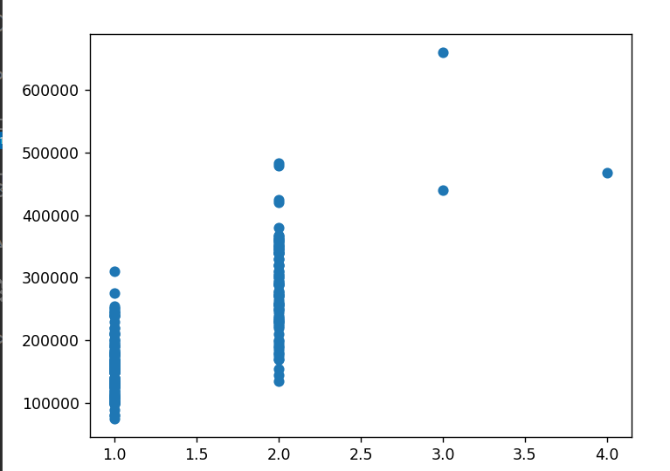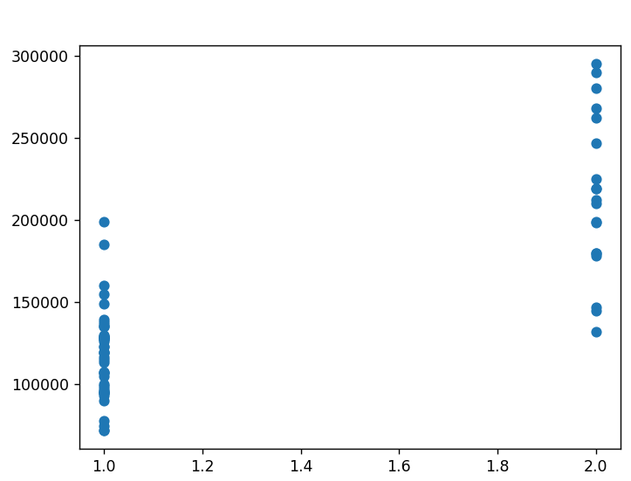

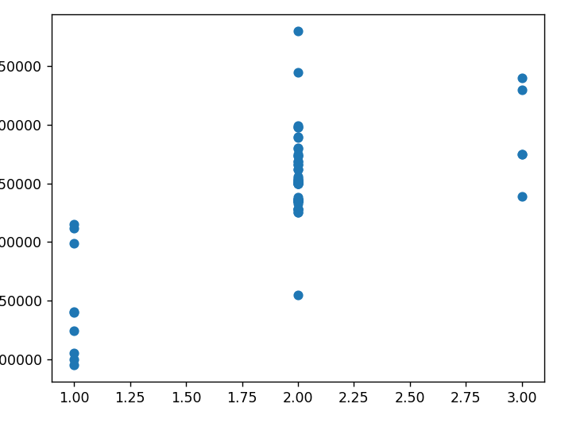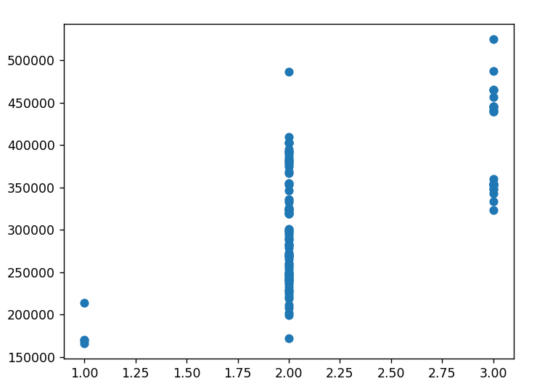

### Floor – Price

There is no a relevant relation.

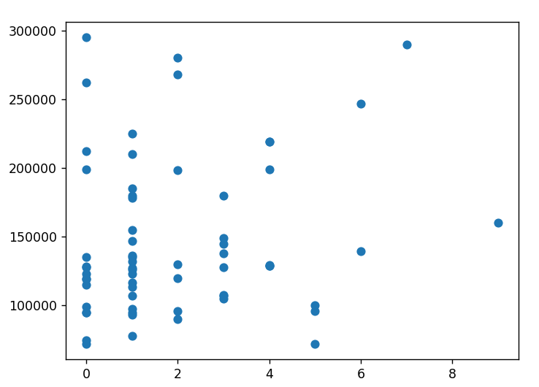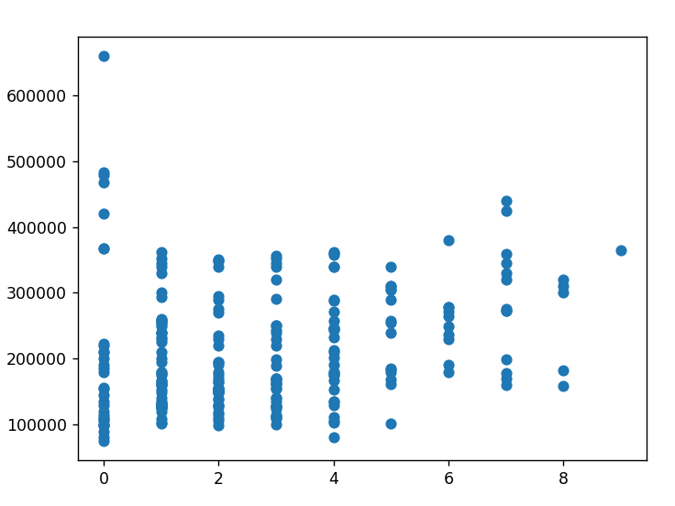

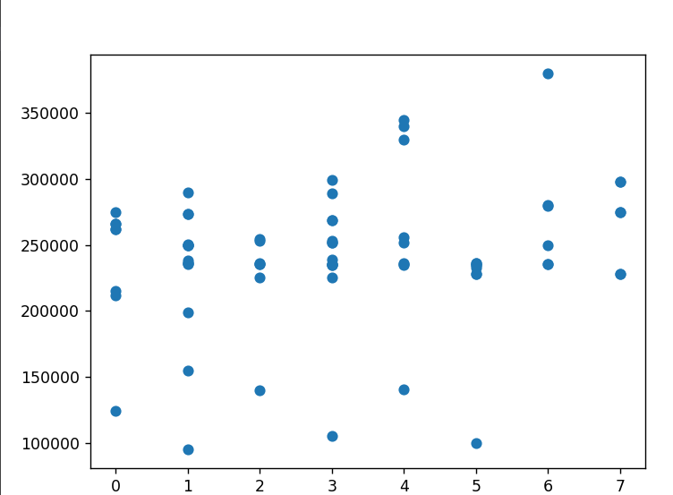

**So, we will use size of the house on square foot, number of bathrooms and number of floors. The relation between the neighborhood and the price is assumed**

## Results in the neighbor of Vallecas

Square meters - Price

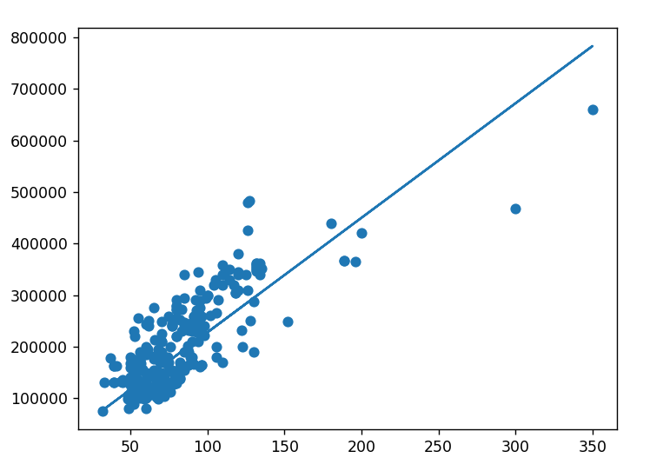

Number of bathrooms - price

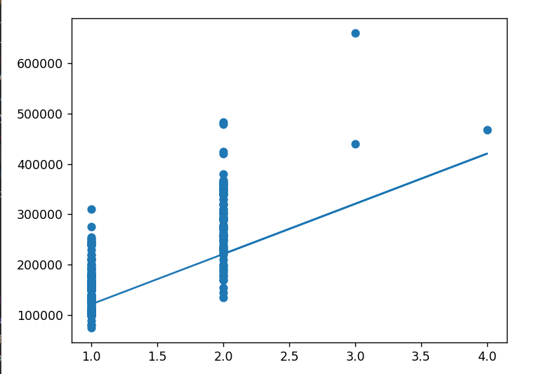

Floor - Price

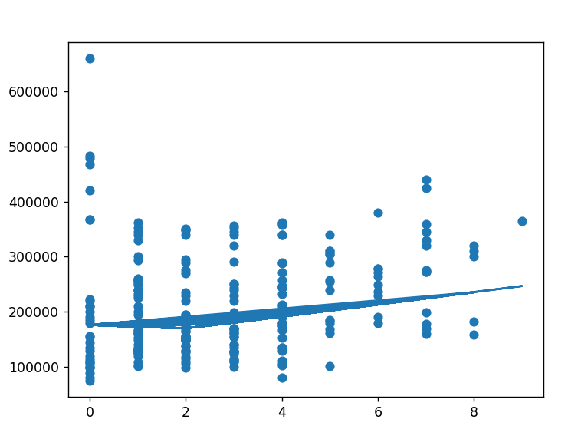

We see that the major predict of a house is the size and the neighborhood